Welcome to use our terminal，please read this manual carefully to install and operate the terminal exactly. This user manual is for reference only. If some contents and operation steps are inconsistent with those for the actual product, the latter will prevail.
Using the GPS tracker, we can position,monitor the vehicle including on the position server via GPRS,GPS and Internet. It can help customers to manage transparently,reduce cost,maintain security and raise efficiency. Now it is widely used in business traffic, logistics distribution,automobile lease, intelligent transportation, shipping market,army and police,rescuing,Safety Supervision,Intelligent city…

Ⅰ. Features & Specifications
■Supports quad bands,
i.e. 850/900/1800/1900MHz, universal in the world.
■Easy to install, connect the OBD interface to work.
■GPS precise positioning with A-GPS and uploaded by GPRS regularly, Supports real-time tracking and history track playback.
■Web browser platform, Smart phone app platform and SMS query.
■Vehicle collision and falling alarm.
■Built-in battery, unplugging alarm.

Basic Specifications

Voltage | 12VDC/24VDC
Standby Current | <10mA@12V
Work current | <40mA@12V
GPS positioning accuracy | 15m
GSM positioning accuracy | 100m
GPS Frequency | 1575MHz
GSM Frequency | 850/900/1800/1900MHz
Hot/warm/cold start time | <3s，<15s，<60s
Battery capacity | 200mAh
Dimensions (mm) | 56.5(L)X 47(W) X 24.6(H)
Operating temperature | -20℃~70℃
Operating humidity | 20%～80%RH
Net Weight | 56 g

Ⅱ. Components & Accessories

2.1 Components
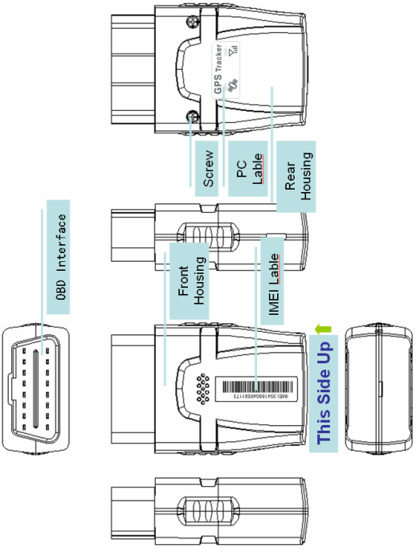

-Top Front(Up side)-

2.2 Accessories
（only for reference）
Screws (standard)
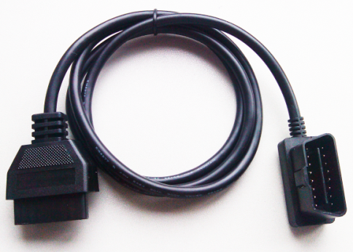
OBD Extension Cable(optional)
Optional accessory for the device, when the OBD interface is not very good and the GPS signal is poor, we can use an extension cable to strength GPS signal.

Ⅲ. SIM card Installation

3.1 Before Installation
3.1.1 Open the packing case, then check if the terminal is OK and the accessories are intact, or please contact your dealer;
3.1.2 Choosing a SIM card: You need a suitable SIM card for using the terminal, please contact your dealer if you have any question;

3.2 Card Installation
Pinch the sides of the front cover with one hand, the other hand gently open the back cover.

Pull down the SIM card cover, Turn the installed SIM card holder door to its original position, gently push the lid with your fingers so it is locked.

Close the back cover, use a screwdriver to packaging the two screws into the the back cover.

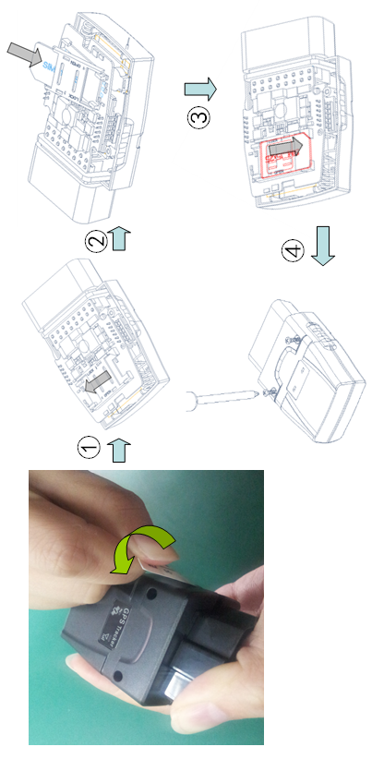

Ⅳ. Set up the terminal

4.1 OBD interface position
In general, OBD interface under the steering wheel, note that some car’s cover.

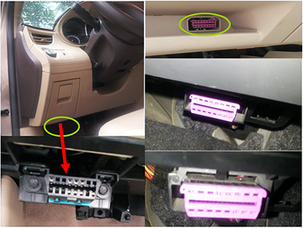

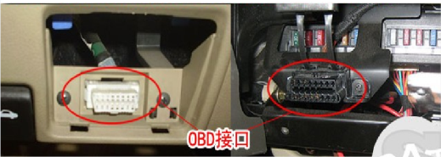

4.2 Terminal Installation
Plug the device in the original car OBD interface can, pay attention to plug tight. Ensure that the top surface of the terminal (receiving side) towards the sky.

4.3 Use Extension cable
After installing the terminal, if the top side can not face the sky, please observe LED, if lights flash constantly, which means that the signal is not good. Use an extension cable connect the device and OBD interface to strength receiving GPS signals.
Make sure the upside upward sky without metal blocks. Suggest to install the terminal in the following places:
1）The hiding place below the front windshield trim panel;
2）The hiding place around the front dash(if the surface is not made of metal);
3）The place under the rear windshield;

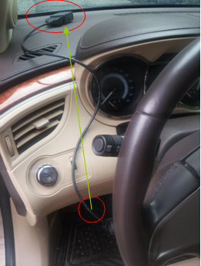

Notice: The GSM and GPS signal may be weakened if there is metal thermal insulation layer or heating layer on the front windshield, the terminal may work abnormally, so please change the place to install the terminal.

Ⅴ. Use the terminal

5.1 Power on
Connect terminal to the vehicle OBD interface and it wll power on.

5.2 LED indicators
The red LED flickers fast when the terminal is searching for GSM network, it flickers intermittently when the terminal has registered the GSM network successfully.
The blue LED flickers fast when the terminal is searching for the GPS satellite signal, it flickers intermittently when the terminal when the terminal has searched the satellites and can be positioned.

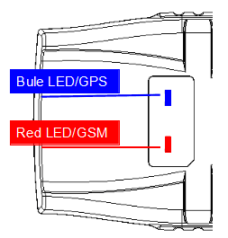

5.21 Red LED(indicates GSM working state)
Fast flicker | Searching for GSM network
Intermittently flicker | GSM/GPRS works normally

5.22 Blue LED(indicates GPS signal state)
Fast flicker | Searching GPS Satellites
Intermittently flicker | GPS works normally

Notice: After power on, LED will turn off in 5 minutes for saving power and the device continues to work , LED will turn on if device receives a phone call and turn off again after 5 minutes.

5.3 Power off
Unplugging the device and take off SIM card for a while.

Ⅵ. Terminal position query

6.1 Inquiry by SMS
You can write a positioning SMS sending to the terminal to inquiry terminal position, the terminal will reply position SMS or map link. The SMS commands please refer to the Operation Commands

6.2 Inquiry by service platform
6.2.1 Web Browser platform
You can login the service platform and enter your ID and password to check the position of the terminal. Please ask your dealer for the WWW address of the position service platform.

6.2.1 Smart phone applications platform
You can use a smart phone to check the terminal’s position.We have prepare for you the Android client (Android), Apple clients (IOS), please check with your dealer to get installation package.

Ⅶ. Terminal Alarm

7.1 Collision / falling Alarm
Conditions: When the Vehicle Collision or falling occurs.

7.2 Unplugging Alarm
Conditions: When the device is unplugged.

7.3 Vibration Alarm
Conditions: When the Vehicle Vibration occurs.
Note: You need to set vibration sensitivity and time, there are arm / disarm switch.

7.4 Speed Alarm
Conditions: When the vehicle over and below the set speed.
Note: You need to set the low speed limit and high speed limit.

7.5 Geo-fence Alarm
Conditions: when the vehicle entry / exit / across the Geo-fence.
Note: You need to set the conditions of crossing fence, fence types and so on.
When above alarm occurs,the terminal will send alarm to service platform, meanwhile send a SMS message to the device administrator or center number.
Note: Some alarm parameters must be set before work,Please refer to the Operation Commands

Ⅷ. Troubleshooting

8.1 Cannot connect to the Service platform
The terminal is never online on the position server after installation . Please check the terminal:
1）If the power cables are wired correctly? Pay attention to not connect them to the controlling cables of the vehicle.
2）If the SIM card is installed correctly? Please refer to the installation instructions.
3）Check the status of the LED indicators. If the terminal is OK, the red LED and the blue LED will intermittently flick.
4）Inquiry the parameters of terminal via commands and check the accuracy of the parameters.

8.2 Show offline status on the Service platform
First check if the LED indicators are OK, if cannot check them, you can check the SIM card following next steps:
1）call the SIM card of the terminal and check if you can hear the connect ring.
2）Check if the vehicle is in the area where there is no GSM signal.
3）Check if one terminal or all terminals are offline in the area where terminal is offline. If all terminals are offline, you should ask the network operator. If the network is OK.
4）Check if the SIM card has enough balance.
5）If the terminal becomes offline on the last day of one month, please check if GPRS is close.
6）Inquiry the parameters of terminal via commands and check the accuracy of the parameters.

8.3 Cannot position for a long time
If the GPS is active, but the terminal cannot be positioned for long time, please check the terminal:
1）If the vehicle is in the place where there is no GPS signal.
2）The GSM and GPS signal may be weakened if the terminal is installed in the place with electromagnetic wave absorption material(such as metal blocks), special attention should be paid if there is metal thermal insulation layer or heating layer on the front windshield, so that the position accuracy will decline, and the severe ones will not be positioned.

8.4 Position drift
Serious position drift will be found in places where GPS signal is poor. Please drive the vehicle to the open places.

8.5 Command receiving abnormally
1）Check the instructions format.
2）Check if the vehicle is in the places where there is GSM signal.
3）Check if the SIM card is properly installed.

Ⅸ.Warranty rules

9.1 Special statement
1）Technology change, without notice.
2) If the color and appearance are inconsistent with those for the actual product, the latter will prevail.
3）Warranty card is only valid for the terminals with the following IMEI.
4）Please take care of the warranty card and show it with the original purchase receipts when enjoying the warranty service.

9.2 Warranty period
Since the date of purchase, passive waste host has one year warranty.

9.3 After sales
Any of the following circumstances not covered by the warranty, but may be appropriate to pay repair:
1）More than the warranty period.
2）Unauthorized removal or repair damaged.
3）Damage caused by improper installation, use, maintenance, custody.
4）The IMEI label is torn or Obscure.
5）Warranty certificate and product models do not match or warranty certificate be altered.
6）Damage caused by force majeure.

Warranty card/保修卡

NAME

TEL

Address

Model

IMEI Number

Selling Uni

Purchase Date YY/ MM/ DD/

Maintenance records | Engineer
 | Completion Date
 | Records
 | Description
 | Date

